On a plane there are n points with integer coordinates points[i] = [xi, yi]. Your task is to find the minimum time in seconds to visit all points.

You can move according to the next rules:

* In one second always you can either move vertically, horizontally by one unit or diagonally (it means to move one unit vertically and one unit horizontally in one second).
* You have to visit the points in the same order as they appear in the array.

**Example 1:**

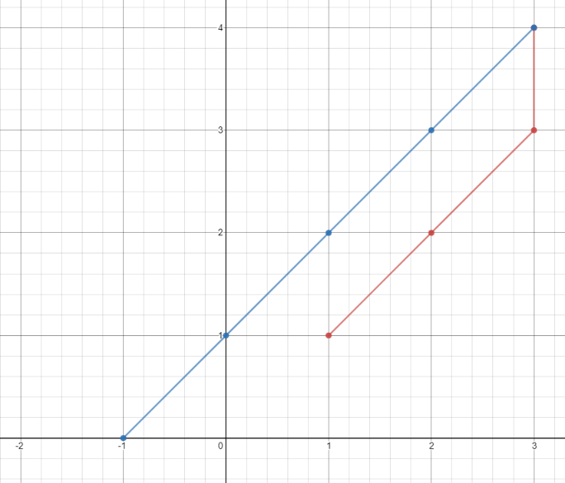

**Input:** points = [[1,1],[3,4],[-1,0]]

**Output:** 7

**Explanation:** One optimal path is **[1,1]** -> [2,2] -> [3,3] -> **[3,4]** -> [2,3] -> [1,2] -> [0,1] -> **[-1,0]**

Time from [1,1] to [3,4] = 3 seconds

Time from [3,4] to [-1,0] = 4 seconds

Total time = 7 seconds

**Example 2:**

**Input:** points = [[3,2],[-2,2]]

**Output:** 5

**Constraints:**

* points.length == n
* 1 <= n <= 100
* points[i].length == 2
* -1000 <= points[i][0], points[i][1] <= 1000